1. Download Tomcat

<https://tomcat.apache.org/download-90.cgi>

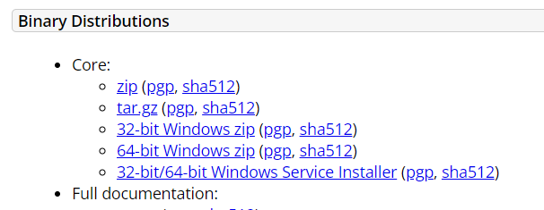

1. Conf/tomcat-users.xml

<role rolename="manager-gui"/>

<role rolename="manager-script"/>

<role rolename="manager-jmx"/>

<role rolename="manager-status"/>

<user username="admin" password="admin" roles="manager-gui, manager-script, manager-jmx, manager-status"/>

<user username="deployer" password="deployer" roles="manager-script"/>

<user username="tomcat" password="s3cret" roles="manager-gui"/>

1. Integrate tomcat with jenkins
2. Install “Deploy to container” plugin
3. Configure tomcat server with credentials

How to change the password of tomcat go to server.xml inside conf folder

<Connector port="8080" protocol="HTTP/1.1"

connectionTimeout="20000"

redirectPort="8443"

maxParameterCount="1000"

Docker pull tomcat

Docker run -d –name tomcat-container -p 8082:8080

Mobin@LAPTOP-5HS2QF1F MINGW64 ~

$ docker run -d --name tomcat-container -p 8082:8080 tomcat

b83e7d60803855d0942cbdd70d329c03d3a3b5df43e5580122326eeed0536eff

Mobin@LAPTOP-5HS2QF1F MINGW64 ~

$ docker ps -a

CONTAINER ID IMAGE COMMAND CREATED STATUS PORTS NAMES

b83e7d608038 tomcat "catalina.sh run" 17 seconds ago Up 16 seconds 0.0.0.0:8082->8080/tcp tomcat-container

Go to browser and type:

Localhost:8082

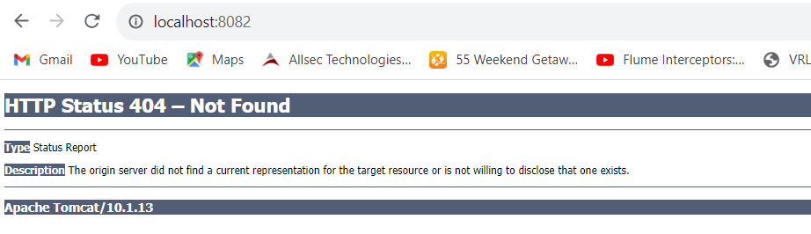

From Git bash it will give below error

Mobin@LAPTOP-5HS2QF1F MINGW64 ~

$ docker exec -it tomcat-container /bin/bash

the input device is not a TTY. If you are using mintty, try prefixing the command with 'winpty'

Go on cmd

To solve this issue you need to copy files from webapps.dist to webapps on :/usr/local/tomcat

C:\Users\Mobin>docker exec -it tomcat-container /bin/bash

root@b83e7d608038:/usr/local/tomcat# ls

bin conf lib logs NOTICE RELEASE-NOTES temp webapps.dist

BUILDING.txt CONTRIBUTING.md LICENSE native-jni-lib README.md RUNNING.txt webapps work

root@b83e7d608038:/usr/local/tomcat# cd webapps

root@b83e7d608038:/usr/local/tomcat/webapps# ls

root@b83e7d608038:/usr/local/tomcat/webapps# cd ..

root@b83e7d608038:/usr/local/tomcat# cd webapps.dist/

root@b83e7d608038:/usr/local/tomcat/webapps.dist# ls

docs examples host-manager manager ROOT

root@b83e7d608038:/usr/local/tomcat/webapps.dist# cp -R ./* ./../webapps/

[root@b83e7d608038:/usr/local/tomcat/webapps.dist#](mailto:root@b83e7d608038:/usr/local/tomcat/webapps.dist)

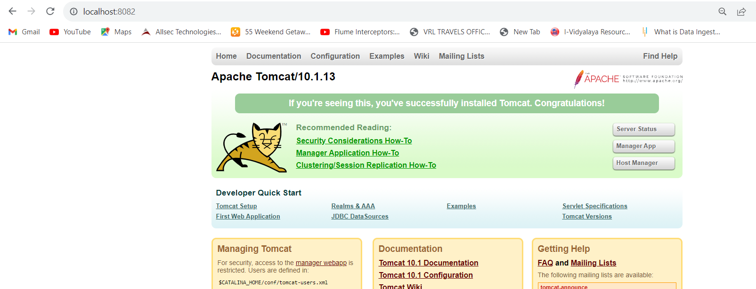

Now if we create new container we will again have to copy the files webapps to resolve that issue

See below I am killing the docker container and creating new container from same imgae:

C:\Users\Mobin>docker ps

CONTAINER ID IMAGE COMMAND CREATED STATUS PORTS NAMES

b83e7d608038 tomcat "catalina.sh run" 14 minutes ago Up 14 minutes 0.0.0.0:8082->8080/tcp tomcat-container

c7fa57993179 mariadb "docker-entrypoint.s…" 7 weeks ago Up 24 minutes (unhealthy) 3306/tcp microservice-mobeenapp-db-1

C:\Users\Mobin>docker stop b83e7d608038

b83e7d608038

C:\Users\Mobin>docker ps

CONTAINER ID IMAGE COMMAND CREATED STATUS PORTS NAMES

c7fa57993179 mariadb "docker-entrypoint.s…" 7 weeks ago Up 24 minutes (unhealthy) 3306/tcp microservice-mobeenapp-db-1

C:\Users\Mobin>

You can see that new docker container is again showing same error so we need to resolve this issue using docker file creation where we will explicitly specify to copy webapps

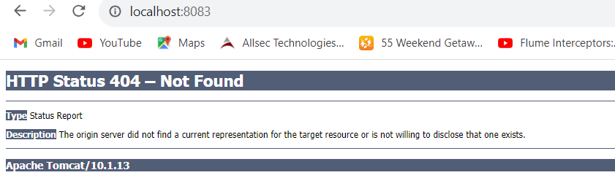

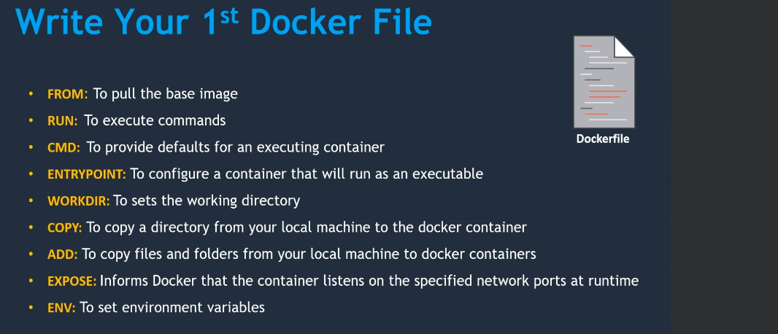

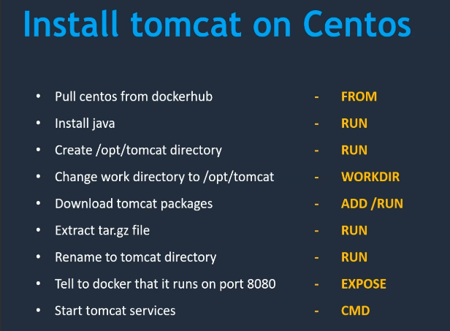

FROM centos:centos7.9.2009

RUN yum -y update

RUN yum install java -y

RUN mkdir /opt/tomcat/

WORKDIR /opt/tomcat

ADD https://dlcdn.apache.org/tomcat/tomcat-9/v9.0.80/bin/apache-tomcat-9.0.80.tar.gz /opt/tomcat

RUN tar xvfz apache*.tar.gz

RUN mv apache-tomcat-9.0.80/* /opt/tomcat

EXPOSE 8080

CMD ["/opt/tomcat/bin/catalina.sh", "run"]

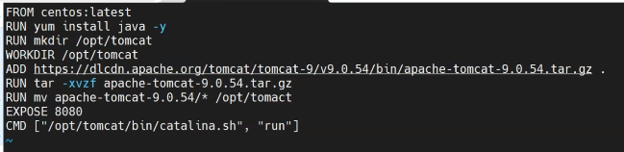

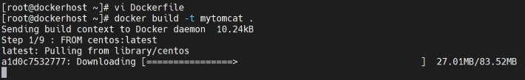

You will get below error if you save dockerfile as txt file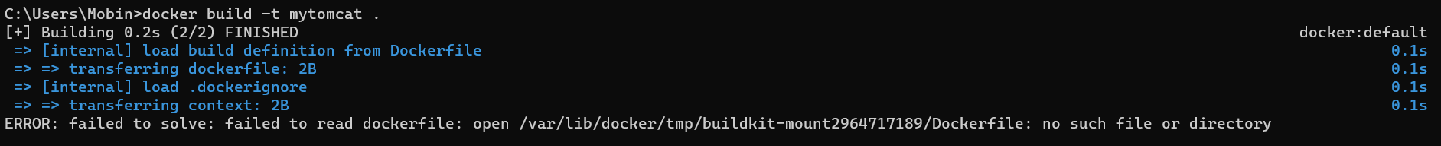

Take the tomcat link from below

https://tomcat.apache.org/download-90.cgi







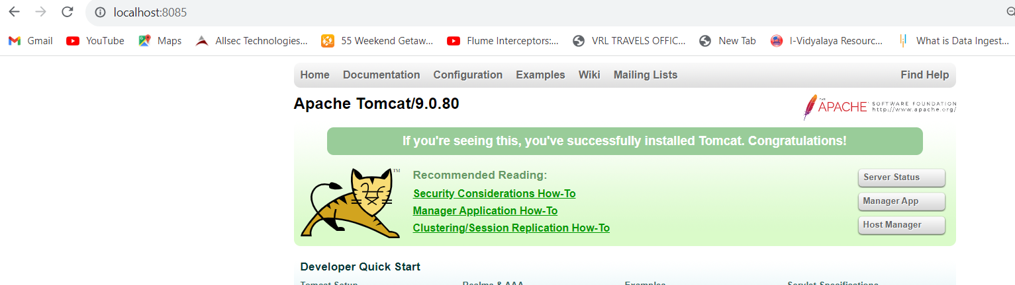

C:\Users\Mobin>docker exec -it 0e1e4c2617f5 /bin/bash

[root@0e1e4c2617f5 tomcat]#

Now one more way to create docker

Vi Dockerfile



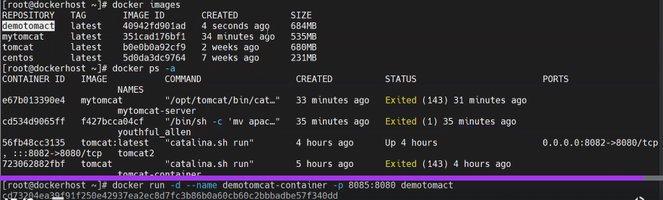

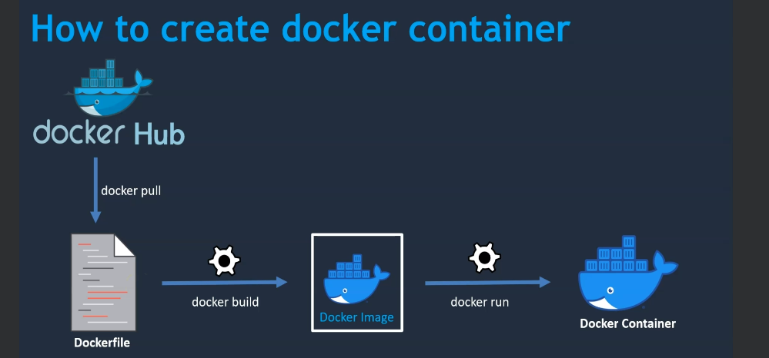

Pushing docker image on hub

docker tag <local_image_name> <your_username>/<repository_name>:<version>

C:\Users\Mobin\Downloads\dockerdemo\Genztech>docker tag mytomcatdemoclass mob1234/tomcat:1.0



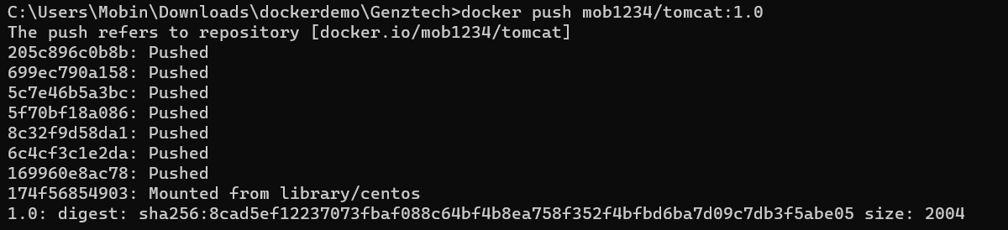

## [Create and manage volumes](https://docs.docker.com/storage/volumes/#create-and-manage-volumes)

**Create a volume**:

$ docker volume create my-vol

**List volumes**:

$ docker volume ls

local my-vol

**Inspect a volume**:

$ docker volume inspect my-vol

[

{

"Driver": "local",

"Labels": {},

"Mountpoint": "/var/lib/docker/volumes/my-vol/_data",

"Name": "my-vol",

"Options": {},

"Scope": "local"

}

]

**Remove a volume**:

$ docker volume rm my-vol

## [Start a container with a volume](https://docs.docker.com/storage/volumes/" \l "start-a-container-with-a-volume)

docker run -d \

--name devtest \

--mount source=myvol2,target=/app \

nginx:latest

Docker Volumes:

docker volume create mydata

docker volume ls

docker run -d –name tomcat1:v1.0 –mount source=mydata,target=/app tomcat1:v1.0

On Windows you can find your mount

Type in the Windows file explorer :

* For Docker version 20.10.+ : \\wsl$\docker-desktop-data\data\docker\volumes
* For Docker Engine v19.03: \\wsl$\docker-desktop-data\version-pack-data\community\docker\volumes\

You will have one directory per volume.

